**Smart Sorting: Transfer Learning for Identifying Rotten Fruits and Vegetables**

**Project Documentation format**

**1. Introduction**

* **Project Title:** [Smart Sorting: Transfer Learning for Identifying Rotten Fruits and Vegetables]
* **Team Members:**

1. Kanuparthi Jagadeesh Reddy [22HM1A0556]
2. Mala Prathima [22HM1A0573]
3. Nalla Nithin [22HM1A0589]
4. Mallu Lokeswara Reddy [23HM5A0510]

**2. Project Overview**

* **Purpose:**

The primary purpose of the Smart Sorting system (NutriGaze) is to develop an intelligent, automated solution for classifying fruits and vegetables as fresh or rotten using image-based machine learning. The project aims to tackle the problem of post-harvest losses and inefficient manual sorting, which often leads to food wastage and quality degradation. By leveraging deep learning with transfer learning (VGG16 model), the system enables accurate, fast, and consistent detection of spoilage, ensuring only high-quality produce reaches retailers and consumers. Ultimately, the project promotes food safety, reduces wastage, enhances operational efficiency, and builds consumer trust in the food supply chain.

* **Goals:**
* To develop an automated image-based system for classifying fruits and vegetables as fresh or rotten.
* To minimize human error and subjectivity in traditional manual sorting processes.
* To reduce post-harvest losses by enabling early detection of spoilage.
* To improve operational efficiency in food processing units, warehouses, and supermarkets.
* To utilize deep learning (transfer learning with VGG16) for accurate, real-time classification.
* To ensure consistent food quality, enhancing consumer safety and satisfaction.
* To build a scalable and reliable solution that can be adapted to large-scale food supply chains.
* To contribute towards reducing food wastage and promoting sustainable consumption.
* **Features:**
* **Image-Based Classification:** Automatically identifies whether fruits and vegetables are fresh or rotten using image processing and deep learning.
* **Transfer Learning with VGG16:** Utilizes a pre-trained VGG16 model, fine-tuned for high accuracy in detecting subtle signs of spoilage.
* **User-Friendly Web Interface:** Simple web application where users can upload images and receive immediate classification results.
* **Real-Time Prediction:** Fast and efficient classification suitable for real-time use in supermarkets, warehouses, and food processing plants.
* **Confidence Score Display:** Provides a confidence percentage with each prediction to indicate model certainty.
* **Supports Multiple Classes:** Capable of detecting freshness or spoilage across various fruits and vegetables, not limited to a single type.
* **Visual Result Presentation:** Displays the uploaded image along with the classification result for easy verification.
* **Extensibility:** Designed to allow easy addition of more fruit or vegetable classes in the future.
* **Prevention of Food Waste:** Helps in early detection of spoilage, reducing wastage and improving food quality control.
* **Scalable Dataset Handling:** Can work with large datasets, making it adaptable for industrial use.

**3. Architecture**

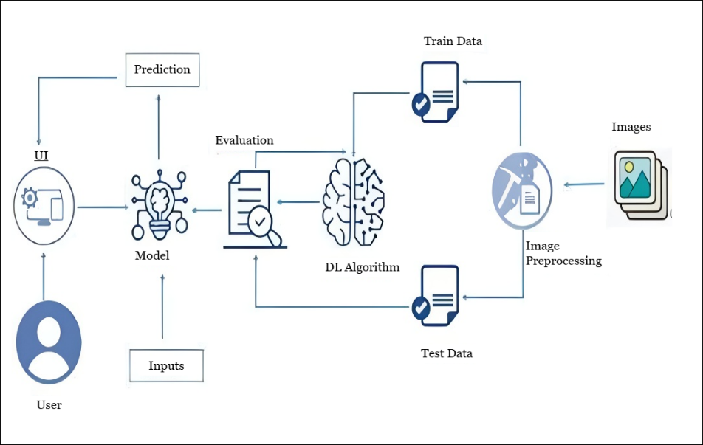

**4. Setup Instructions**

* **Prerequisites**:

To complete this project, you must require the following software and packages.

* + Software Requirements:
    - Visual Studio Code (VS Code) or any Python-supported IDE
    - Python 3.10 for better suitable to all packages
  + Python packages:
  + Open VS code terminal prompt etc.,
  + Type “pip install numpy” and click enter.
  + Type “pip install pandas” and click enter.
  + Type “pip install scikit-learn” and click enter.
  + Type “pip install matplotlib” and click enter.
  + Type “pip install scipy” and click enter.
  + Type “pip install seaborn” and click enter.
  + Type “pip install tenserflow” and click enter.
  + Type “pip install Flask” and click enter.
* **Installation:**

1. Create a Virtual Environment (Optional but Recommended):

python -m venv .venv

source .venv/Scripts/activate For Windows

source .venv/bin/activate For Mac/Linux

1. Install Required Packages:

Ensure you run:

pip install numpy

pip install pandas

pip install scikit-learn

pip install matplotlib

pip install scipy

pip install seaborn

pip install tensorflow

pip install Flask

pip install Pillow

1. Download Dataset:

Place the dataset inside the `data` folder or run your `dataset_downloader.py` to fetch from Kaggle.

1. Prepare the Dataset:

python data_preparation.py

1. Clean the Dataset (Optional for Transparency Issues):

python rgb_cleaner.py

1. Train the Model:

python model_training.py

1. Test the Model (Optional):

python model_testing.py

1. Run the Flask Web Application:

python app.py

1. Access the Application:

Open your browser and visit: [http://127.0.0.1:5050]

**NOTE:** After successful setup, you can upload fruit or vegetable images through the web interface to detect freshness or spoilage.

**5. Folder Structure**

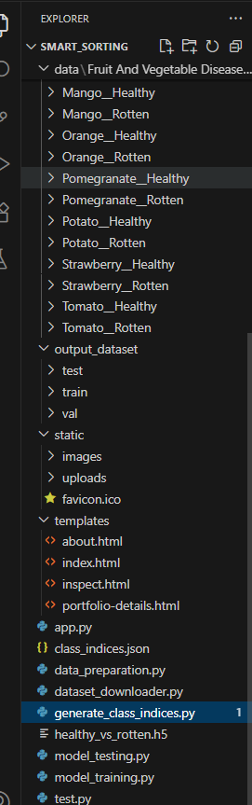

**6. Running the Application**

1. **Backend (Flask Application):**

The Flask backend serves both the API and the frontend templates (HTML pages).

Commands to run the backend:

Open the terminal (preferably inside your project directory).

Activate the virtual environment if created:

source .venv/Scripts/activate # For Windows

source .venv/bin/activate # For Mac/Linux

Run the Flask application:

python app.py

The server will start at:

http://127.0.0.1:5050

1. **Frontend:**

The project uses Flask's Jinja templates (index.html, about.html, inspect.html) for the frontend. No separate command is needed for the frontend. Once the Flask server starts, the frontend will be accessible through your web browser at:

<http://127.0.0.1:5050>

The following endpoints are exposed by the Flask backend for the NutriGaze application:

**7. API Documentation**

1. **Home Page**

* **URL:** /
* **Method:** GET
* **Description:** Displays the landing page of the application.
* **Response:** Returns the index.html template.

1. **About Page**

* **URL:** /about
* **Method:** GET
* **Description:** Displays information about the project.
* **Response:** Returns the about.html template.

1. **Inspect Page (Upload & Predict UI)**

* **URL:** /inspect
* **Method:** GET
* **Description:** Displays the image upload form for prediction.
* **Response:** Returns the inspect.html template.

1. **Image Prediction API**

* **URL:** /predict
* **Method:** POST
* **Description:** Accepts an image file, performs classification using the trained model, and returns the prediction.

**Request Parameters:**

|  |  |  |
| --- | --- | --- |
| **Name** | **Type** | **Description** |
| image | File | The image file to be uploaded (JPG, PNG, etc.). |

**Example Request using HTML Form:**

<form method="POST" action="/predict" enctype="multipart/form-data">

<input type="file" name="image" required>

<button type="submit">Predict</button>

</form>

**Example Response (Rendered on Inspect Page):**

Upon successful prediction, the following details are displayed:

* Uploaded image preview
* Predicted class label (e.g., "Apple__Healthy")
* Confidence score (percentage)

**Example Backend Response (if it were JSON API):**

(Note: Your current implementation renders a template, but if converted to pure JSON API, it would look like this)

{ "predicted_label": "Banana__Rotten",

"confidence": 97.35,

"image_path": "static/uploads/banana.jpg"

}

**8. Authentication**

**Current Status:**

The current version of the NutriGaze project does not implement authentication or authorization mechanisms. The application is designed as a publicly accessible image classification tool intended for demonstration purposes, allowing any user to:

✔ Access the website

✔ Upload images for freshness classification

✔ View results without requiring login or registration

**Future Scope for Authentication (Optional Enhancements):**

For improved security and controlled access in future versions, the following authentication and authorization methods can be implemented:

|  |  |
| --- | --- |
| **Method** | **Description** |
| **Session-Based Authentication** | User credentials are verified on login, and a secure session is maintained using cookies. |
| **Token-Based Authentication (JWT)** | Users receive a JSON Web Token (JWT) upon successful login, which must be provided with each request to access protected resources. |
| **Role-Based Access Control (RBAC)** | Different user roles (e.g., Admin, Food Plant Head, Supermarket Manager) can be defined to restrict or grant access to specific features. |

**Recommended Future Features:**

* Admin Login: Only authorized personnel can retrain or upload new datasets.
* User Dashboard: Registered users can track prediction history.
* API Access Tokens: Protect REST APIs for mobile or external application integration.

**9. User Interface**

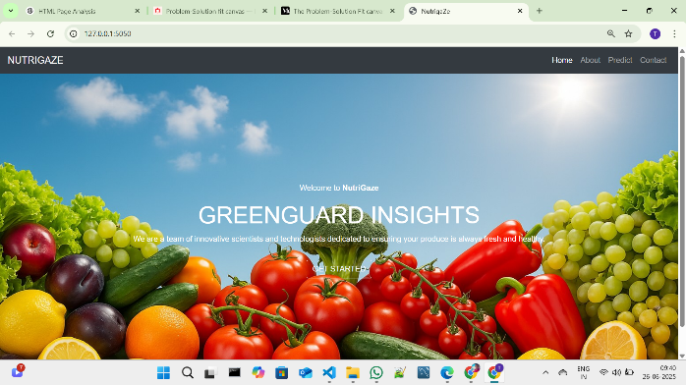 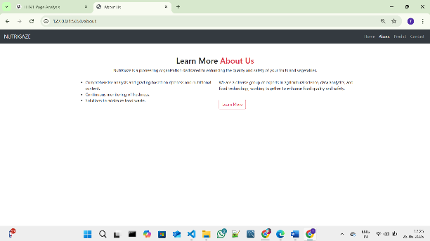

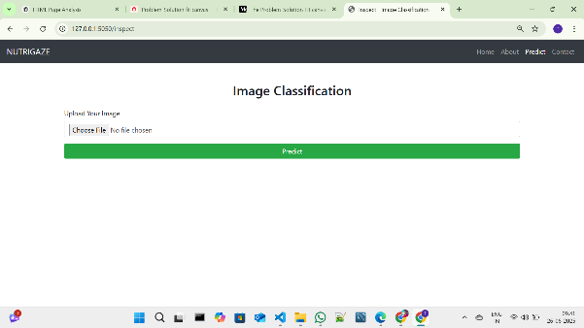

**10. Testing**

**Testing Strategy**

To ensure the robustness and accuracy of the NutriGaze fruit and vegetable freshness classification system, a combination of manual and automated testing techniques were used:

* **Model Evaluation Testing:**
* Evaluated the trained deep learning model using separate validation and test datasets.
* Performance metrics such as accuracy, confusion matrix, and classification report were generated.
* **External Image Testing:**
* Manually tested the model by uploading real-world images not included in the training dataset.
* Observed model predictions to assess generalization ability.
* **Web Application Functional Testing:**
* Tested all web pages (Home, About, Predict) for correct navigation and content display.
* Verified image upload functionality through the web interface.
* Ensured correct prediction results and image preview on the Inspect page.

**Tools Used**

|  |  |
| --- | --- |
| **Tool/Library** | **Purpose** |
| **TensorFlow/Keras** | Model training, evaluation, and predictions. |
| **scikit-learn** | Generated confusion matrix and classification reports. |
| **Matplotlib/Seaborn** | Visualization of confusion matrix and performance metrics. |
| **Flask (Debug Mode)** | Web application testing and debugging. |
| **Manual Testing** | Verified functionality of file uploads and predictions through browser. |

**11. Screenshots or Demo**

**Screenshots**

The complete execution of the Smart Sorting application is shown in the images step by step as shown below.

**Step 1:** Run the app.py code and you will get a link in terminal as <https://127.0.0.1.5050> to access web page and to do the other process.

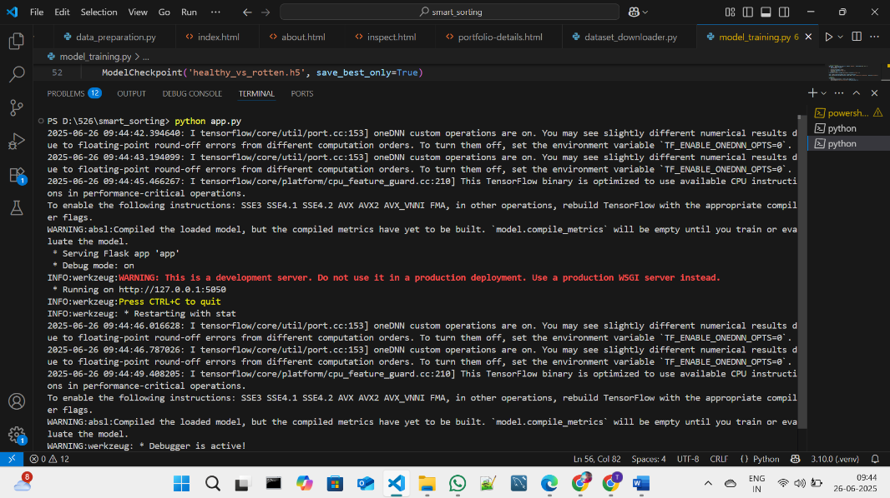

**Fig 7.1.1: Code running in Terminal**

**Step 2:** Click on that link a web page of Nutrigaze will be open in the web browser.

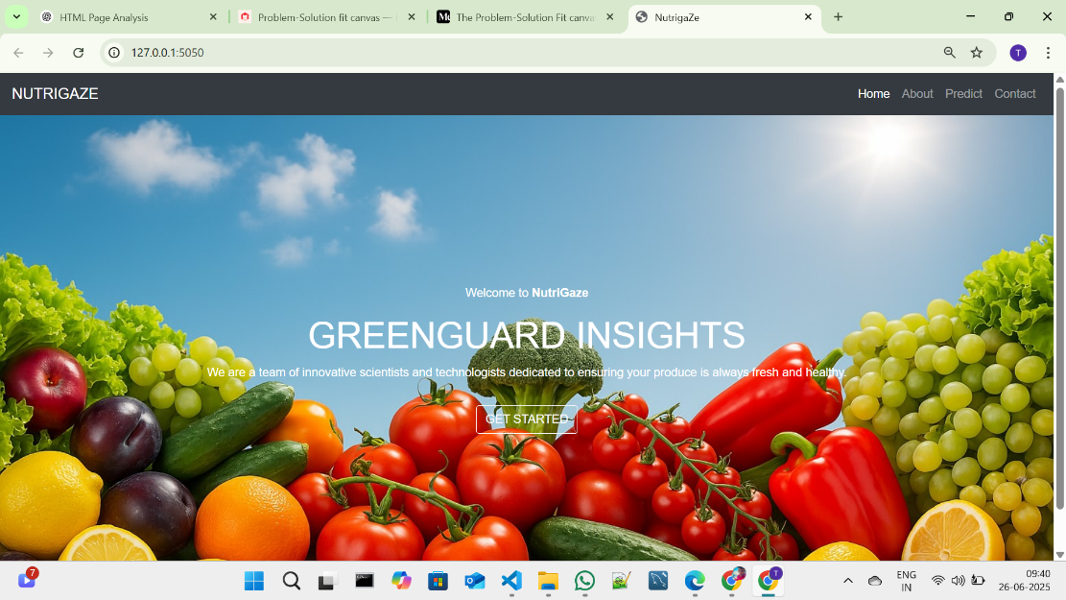

**Fig 7.1.2: NUTRIGAZE Home Page**

**Step 3:** Click on GET STARTED or PREDICT option to open the prediction page.

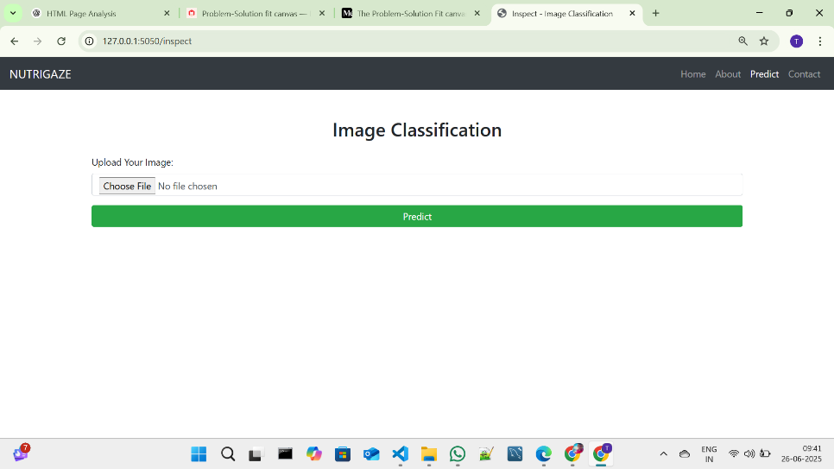

**Fig 7.1.3: Prediction page in NUTRIGAGE**

**Step 4:** Click on choose file option to choose the images that need to predict.

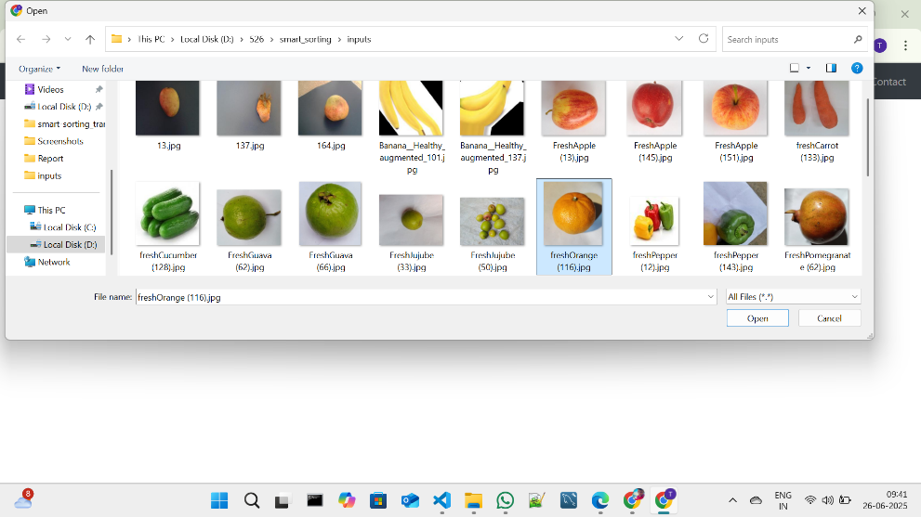

**Fig 7.1.4: Window to choose image for prediction**

Select any image for prediction and click on Open.

**Step 5:** Click on Predict to predict the quality of selected image.

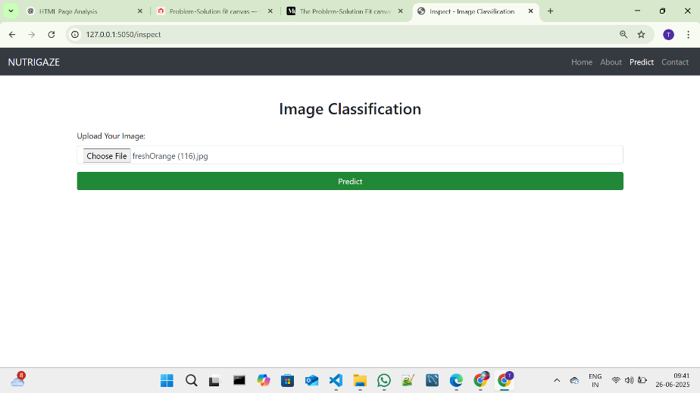

**Fig 7.1.5: Image selected in prediction page**

**Step 6:** After clicked on the predict button the model predicts the image quality and displays the quality of image.

The below images are the some of samples tested for prediction.

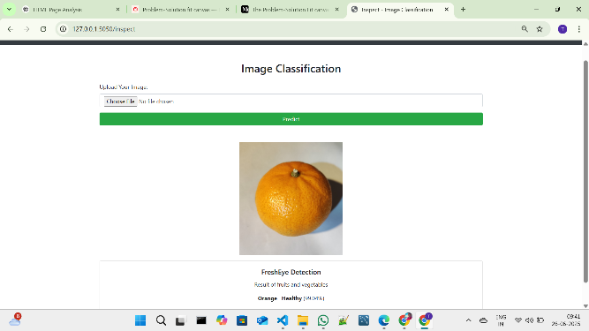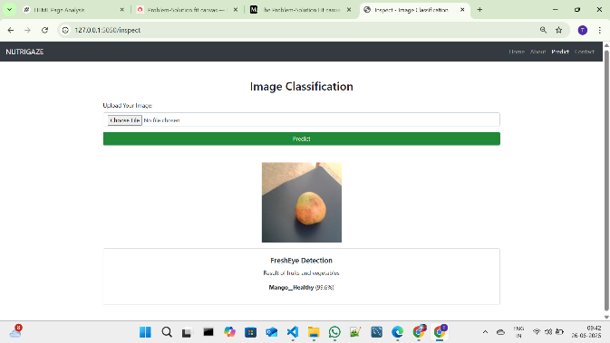

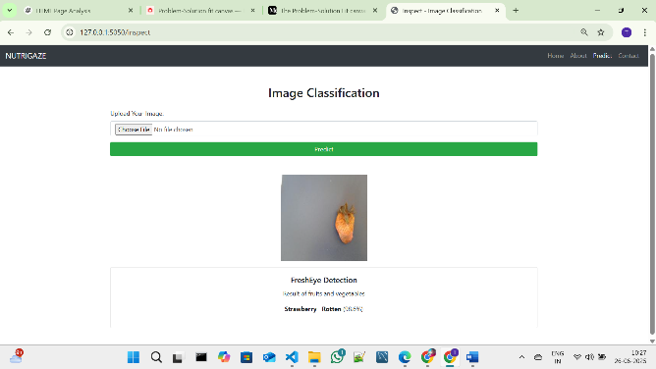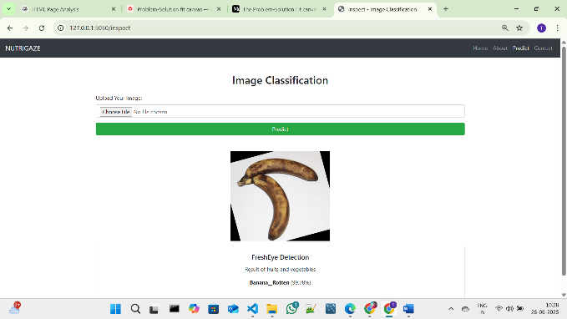

**Fig 7.1.6: Prediction output for the several inputs with accuracy**

After the Images Predicted the images will be stored in the uploads folder as fresh and rotten as shown in the figure given below.

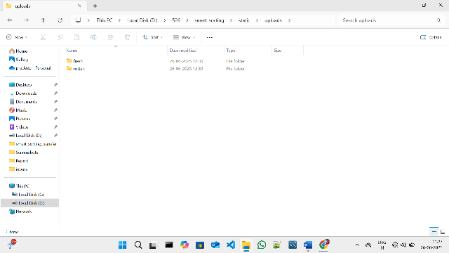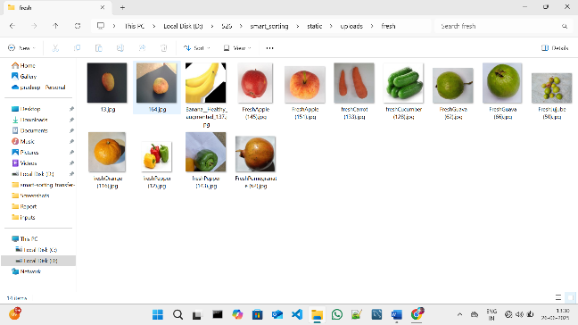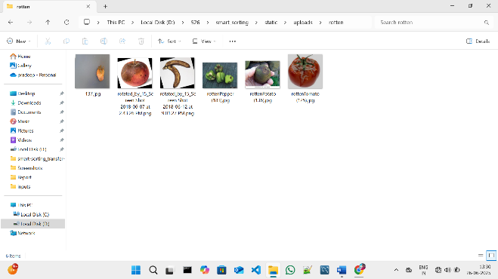

**Fig 7.1.7: Folder Structure to store predicted images**

**Project Demo Link:**

<https://drive.google.com/file/d/1rH_paFk48Vpvd5Iwx-PqjCrR9244i3DS/view?usp=drivesdk>



**12. Known Issues**

**Functional Issues**

* **Model Misclassification:**  
  The model occasionally misclassifies images that have poor lighting, background clutter, or images taken from unusual angles.
* **Confidence Variability:**  
  Predictions on external, real-world images sometimes produce low confidence scores even when the classification is correct.

**File Handling Issues**

* **Duplicate File Names:**  
  If a user uploads a file with the same name as an existing file in the static/uploads/fresh/ or static/uploads/rotten/ directories, the existing file will be overwritten.

**UI/UX Issues**

* **Image Display Delay:**  
  In some cases, large image files may take a few extra seconds to display after prediction due to processing and browser loading time.
* **No Image Preview Before Submission:**  
  Users cannot preview the image before submitting it for prediction.

**Security Issues**

* **No File Type Validation:**  
  The current system does not strictly validate uploaded file types, which may allow unsupported or malicious files to be uploaded.

**13. Future Enhancements**

**Model Improvements**

* **Enhanced Model Accuracy:**  
  Train the classification model on a larger and more diverse dataset to improve prediction accuracy, especially for external or real-world images.
* **Multi-Class Classification:**  
  Extend the model to classify not just fresh or rotten but also detect specific defects, diseases, or categorize different types of fruits and vegetables.

**Web Application Features**

* **Image Preview Before Submission:**  
  Add functionality to allow users to preview uploaded images before submitting them for prediction.
* **Drag and Drop Uploads:**  
  Improve user experience by supporting drag-and-drop image uploads.
* **Batch Prediction:**  
  Enable users to upload multiple images at once and receive predictions for all of them.

**File Management**

* **Automatic File Renaming:**  
  Implement a system to avoid overwriting existing files by appending timestamps or unique IDs to uploaded file names.
* **Image History & Gallery:**  
  Provide users with access to previously uploaded images and their prediction results.

**Security Enhancements**

* **Strict File Validation:**  
  Ensure that only valid image files (e.g., .jpg, .png) are accepted to prevent potential misuse.
* **Authentication & User Management:**  
  Implement user login and role-based access control to secure the application for different types of users (e.g., Admin, General User).

**Reporting & Analytics**

* **Downloadable Reports:**  
  Generate downloadable reports (e.g., PDF or CSV) summarizing predictions made during a session.
* **Usage Analytics:**  
  Track application usage statistics, such as number of images analyzed, classification distribution, etc.

**Deployment & Scalability**

* **Cloud Deployment:**  
  Deploy the application to a cloud platform (e.g., AWS, Heroku) for public access.
* **Mobile-Friendly Design:**  
  Optimize the web interface for mobile devices to improve accessibility.